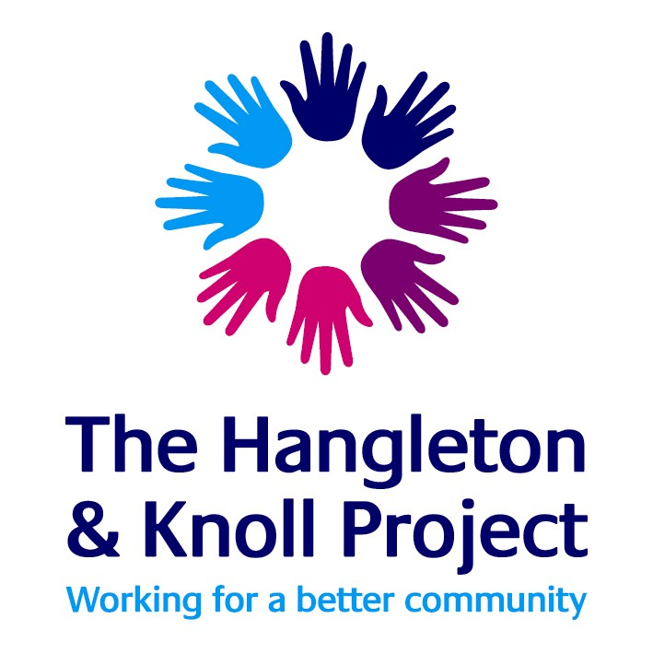
The Hangleton and Knoll Project Office
St Richards Church and Community Centre
Egmont Road
Hove
BN3 7FP

Dear Parent / Carer

A warm welcome to The Hangleton & Knoll Youth Project
To allow young people to attend our youth sessions and clubs safely please complete the membership form available on the website. Please bring the completed form along on your first visit or post the form to the address above for approval. Alternatively come along to a session and we can give you a form and provide support to join. Annual Membership is free for young people aged 11 – 19 years’ old and up to age 25 for those with special education needs and disabilities (SEND) which includes the following;
- Free access to all of our youth sessions, clubs and holiday programmes
- Subsidised / free trips
- Access to supported volunteering opportunities
All activities are risk assessed and staffed by experienced and qualified youth workers who are first aid trained and DBS checked. Our sessions are mainly delivered in Hangleton, Knoll and Portslade areas.

Disclaimer
Your child / young person will be signing up to agree to a mutually respectful relationship with youth workers and our members. We have posted our expectations on the website to download and sign up to. Any child / young person who does not meet expectations will be given an appropriate ‘cooling off’ period to reflect and work with us to improve circumstances. Young people can also expect a safe and supported reporting/complaints process should they feel they have been treated unfairly or are concerned about a worker and all issues raised will be taken seriously and dealt with in a professional manner in line with our organisation’s policies.
Safety is our priority but above all we hope our members will enjoy learning and leisure opportunities that aim to support their personal development, health and well-being. If you want to know more, please do not hesitate to contact us. All our policies are available on request. To keep up to date with what’s on offer please follow and like us on our social media or visit our website:

Facebook: https://www.facebook.com/HKPYouthteam
Instagram: @hkpyouthteam
www.hkproject.org.uk

Kind regards

The Youth Team

